## Mission Architecture

Table 1. Boeing Colony-II Bus capabilities and constraints.

|  |  |
| --- | --- |
| **Parameter** | **Payload Accommodation/Space Vehicle Performance** |
| Design Life | 1 to 3 Years |
| Payload Mass | Up to 1.83 kg |
| Payload Power | 4 Watts |
| Payload Size | 1U |
| Pointing Control | 0.42 deg |
| Mass Data Storage | 8 GB |
| Launch Environment | CubeSat GEVS standard |

With mission success defined, as well as the scope of the mission being limited to small spacecraft, it was determined that the Rascal mission need to be executed through the use of a CubeSat architecture. Based on these success criteria, it was determined that the Rascal mission could be executed through the use of two 3U CubeSats. One of these spacecraft would be designated at the interceptor, the other the target. The interceptor will be an active spacecraft that will carry a propulsion system and an active attitude determination and control system. The target spacecraft will be passive, with no propulsion or active ADC. Instead it will serve as place for the interceptor spacecraft to interact with and dock.

This mission will be developed in conjunction with Boeing, where they will be providing a their Colony-II bus for the interceptor, whose specifications are defined in Table 6. The payload for the interceptor, target spacecraft, and the docking mechanism will be developed by Saint Louis University. As defined by the Colony-II constraints, the payload will be a 1U that is to provide navigation and control relative to the target spacecraft, with the mission requirements defined by Saint Louis University. With this in mind, the layout of the 1U payload allows space for an imaging capturing and processing board (for calculating the relative distance and velocity between each spacecraft), interface control board (for independent operation and handling of said image board, as well as for interfacing with the Colony-II bus), inter-satellite communication board (for the sharing the target spacecraft's location and the relaying of satellite health through either spacecraft), and a propulsion unit (that will provide 3-axis control).

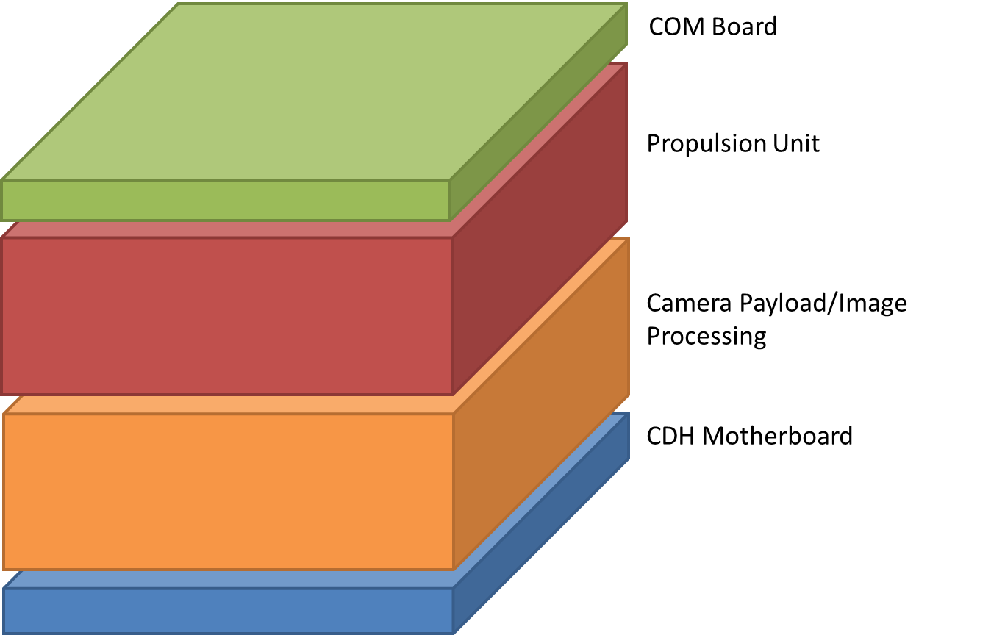Figure 1: Example Rascal 1U payload layout

Since the target spacecraft is not as complex, it will have a component layout similar to the payload. Target spacecraft will carry a GPS receiver, so it can determine its location and broadcast it during the cooperating phase of the mission. There will be a radio to broadcast the GPS location to the interceptor spacecraft. A payload will provide visual aids for the interceptor spacecraft to image. The motherboard will be used to control all the components. In addition, it will have a power system to power the components, consisting of a power management board and enough batteries to last the duration of the mission. The target spacecraft will also have a passive ADC system to reduce that the spacecraft many experience, the interceptor spacecraft can dock.

Both spacecraft will carry components for the conjoining and docking mechanisms. The conjoining mechanism will serve to keep the two spacecraft together until mission start is initiated. The docking mechanism, which will primarily be hosted on the target spacecraft, will provide docking for interceptor spacecraft as the need arises and when the mission dictates.

Figure 2: Example Rascal Target Spacecraft Layout